



PRELIMINARY EXAMINATION 2019  
: ENGLISH LANGUAGE.

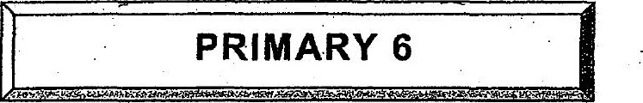



There are a-total of 80 questions — 28 MCQ and 52  
open-ended questions.

